Functional Design Overtopping Mechanism (CONCEPT)

© Deltares, 2012

Computer Services
Title

Prepared for:
Deltares
Title
VTV Tool
Computer Services
Report
Date

Client |  | Deltares
Title
Abstract
References
Ver | Author |  |  | Date | Remarks | Review |  | Approved by
Project number
Keywords
Number of pages
Classification
Status

wlL5 wlSummary

Contents
wlL2 wlL1 wlL3 wlL4
1 Introduction 3
2 General Program Structure 3
2.1 Input data 3
2.2 Output data 3
2.3 Program steps 4
3 Input parameters and cross section 4
3.1 Load parameters and model factors 4
3.2 Cross section data 5
3.3 Merging two sequential berms 6
3.4 Calculate influence factors angle of wave attack 7
3.5 Split cross section for at least one wide berm 7
3.6 Start specific computation for cross section 8
3.7 Combine computation results for cross sections 9
4 Computation method 9
4.1 Calculation steps 9
4.2 Detailed functions 10
4.2.1 Adjustment of non-horizontal berms 10
4.2.2 Calculate 2% wave run-up 11
4.2.3 Calculate representative slope angle 12
4.2.4 Calculate influence factor roughness on slope 13
4.2.5 Calculate influence factor berms 13
4.2.6 Calculate influence factor one berm 14
4.2.7 Combine influence factors berms 16
4.2.8 Calculate adjustment of influence factors 17
4.2.9 Calculate wave overtopping discharge 18
5 Foreshore 19
6 References 20
wlListTabs wlListFigs wlListPhotos wlListSymb

Introduction
This document is the Functional Design of the RTO overtopping module. This module has two objectives:
- to be called from a stand alone application such as RingToets
- to be called in a probabilistic environment such as Hydra-Ring.

The output of the RTO overtopping module is the 2% wave run-up and the overtopping discharge. No information about failure is derived.

This Functional Design is based on two documents [TAW, 2002] and [TDR, 2005]. The assumption is made that the contents of these two documents is correct. All relevant elements of these two documents for the RTO overtopping module are described in the next chapters. Chapter 2 gives the general program structure. Chapter 3 discusses the input parameters and the cross section. Chapter 4 gives the general calculation method and chapter 5 gives the computation method for berms which are that wide that they are in fact foreshores.

General Program Structure
This chapter describes the input/output of the program and the program structure in general. More details (especially for the input data requirements and the calculation procedure) are given in the following chapters.

Input data
The input for the RTO overtopping module consists of:
- Load parameters
- Cross section data
- Model factors

The load parameters are the still water level and the wave parameters at the toe of the dike. Any reduction of the wave parameters due to the presence of a foreland has to take place before the wave parameters are given as input to the overtopping module. In other words: the calculation of the wave reduction through a foreland is not part of this program.

Since no foreland is used within the overtopping module, the cross section consist only of dike segments from the toe of the dike to the outer crest level. These segments are given by the (x,y)-coordinates and have to satisfy certain boundary conditions (section 3.2). The roughness reduction factors for the different dike segments are also part of the input data, as is the outer normal (the orientation) of the dike, which is necessary to determine the angle of wave attack.

Finally some model factors (used in the calculation of the wave run-up and overtopping) are part of the input data of the module. For more details we refer to section 3.1.

Output data
The output of the RTO overtopping module consists of:
- Main results
- Calculation data
- Error information

The main results are the 2% wave run-up (in m) and the overtopping discharge (in l/m per s). The calculation data are the intermediate results of the calculation, including all the influence factors and the results of each iteration step in the calculation procedure (section 4.1). The error information consists of an code (flag for success) and an error message (for failure).

Program steps
The general program structure of the RTO overtopping module consists of the following steps:
Read load parameters, cross section data and model factors
Check load parameters and model factors section 3.1 (page 4)
Check cross section data section 3.2 (page 5)
If applicable merge two sequential berms section 3.3 (page 6)
Calculate influence factors angle of wave attack section 3.4 (page 7)
If the cross section contains at least one wide berm split
the cross section into two different cross sections section 3.5 (page 7)
Start computation for each cross section section 3.6 (page 8)
If applicable combine results for all cross sections section 3.7 (page 9)

Input parameters and cross section
This chapter describes the input parameters for the RTO overtopping module, including the cross section of the dike. The boundary conditions for these data are given, and also a description of the procedure to check the input data for the cross section. Finally, a procedure is given to make necessary adjustments to the cross section as a pre-processing step before the actual calculation of the wave run-up and overtopping.

Load parameters and model factors
The following load parameters and model factors are required:

SWL | Still water level (i.e. local water level) | (m+NAP)
H_{m0} | Significant wave height | (m)
T_{m-1,0} | Spectral wave period | (s)
ϕ | Wave direction | (° w.r.t. North)
f_{run-up1} | Model factor wave run-up 1 (1.75 in [TAW, 2002], formula 3a) | (-)
f_{run-up2} | Model factor wave run-up 2 (4.3 in [TAW, 2002], formula 3b) | (-)
f_{run-up3} | Model factor wave run-up 3 (1.6 in [TAW, 2002], formula 3b) | (-)
f_{b} | model factor for breaking waves (4.3 in [TAW, 2002], formula 22, page 28) | (-)
f_{n} | model factor for non-breaking waves (2.3 in [TAW, 2002], formula 23, page 28) | (-)
f_{swallow} | model factor for shallow waves (0.21 in [TAW, 2002], formula 26, page 33) | (-)

The following checks are made on the input data mentioned above:
- Significant wave height: 0 < H_{m0} < 10 ([TDR, 2005], section 6.2.2)
- Spectral wave period: 0 < T_{m-1,0} < 25 ([TDR, 2005], section 6.2.2)
- Wave steepness: 0.001 < s₀ < 0.07 ([TDR, 2005], section 6.2.2)
- Wave direction: 0 < ϕ < 360

Where the wave steepness is defined as: s₀ = 2π H_{m0} / (g T²_{m-1,0}) ([TAW, 2002], page 8)

Cross section data
For a cross section the following data is required:

ψ | Dike normal | (° w.r.t. North)
x | x-coordinates cross section (x₁,..., x_{N}) | (m)
y | y-coordinates cross section (y₁,..., y_{N}) | (m+NAP)
r | roughness factor dike segments (r₁,..., r_{N-1}) | (-)

Note:
- (x₁,y₁) is the toe of the cross section.
- (x_{N},y_{N}) is the crest of the cross section.

The following boundary conditions apply on the input data mentioned above:
- The number of x-coordinates must match the number of y-coordinates (it has to be > 2)
- The x-coordinates must increase: x_{i+1} > x_{i}
- The minimum distance between x-coordinates is 2 m: x_{i+1}-x_{i} ≥ 2
- The y-coordinates must be non-decreasing: y_{i+1} ≥ y_{i}
- Dike segments are either slope segments or berm segments:
- Slope segments have a minimum gradient of 1:8 and a maximum of 1:1
- Berm segments have a maximum gradient of 1:15
- A maximum of two berm segments is allowed
- The first and the last dike segment has to be a slope segment (1:8 ≤ gradient ≤ 1:1)
- The number of roughness factors (in r_{dike}) must equal the number of segments, that is: the number of (x,y)-coordinates minus 1.
- The roughness factors must lie between 0.5 and 1.0 ([TDR, 2005], section 6.2.1)

Opmerking
Ten aanzien van de ondergrens van de ruwheid spreekt [TDR, 2005] zichzelf tegen. De ondergrens van 0.5 voor een profieldeel wordt inderdaad in sectie 6.2.1 genoemd. Op de pagina's 26 en 28 van [TDR, 2005] wordt echter uitgegaan van een ondergrens van 0.55 voor de ruwheid van het (gehele) profiel. De ondergrens van de ruwheid van een profieldeel wordt in [TAW, 2002] niet genoemd. Wel is in bijlage 1 van [TAW, 2002] een lijst met ruwheden opgenomen voor verschillende toplagen. De kleinste waarde hierin is 0.55. Hieraan lijkt [TDR, 2005] conclusies verbonden te hebben.

Opmerking
Bijlage J van [Duits en Kuijper, 2012] geeft de voorwaarden die Hydra-Zoet stelt aan een dijkprofiel. Deze voorwaarden zijn in deze sectie overgenomen. In [Duits en Kuijper, 2012] ontbreekt echter één voorwaarde, die de applicatie Hydra-Zoet wél stelt aan dijkprofielen: van de applicatie Hydra-Zoet mogen bermen niet aansluitend zijn. Bij een volgende release van Hydra-Zoet zal deze voorwaarde aan Bijlage J van [Duits en Kuijper, 2012] toegevoegd zijn. Toevoeging van deze (ontbrekende) voorwaarde aan deze sectie is één van de mogelijkheden om hiermee om te gaan. Een andere mogelijkheid is om wel toe te staan dat de twee bermen aansluitend zijn. Dan zullen regels opgesteld moeten worden hoe hier mee om te gaan. Voorstel is om deze twee bermen te combineren tot één berm. Dit is uitgewerkt in paragraaf 3.3. Dit is conform paragraaf 6.6 van [TDR, 2005]. Al zegt [TDR, 2005] niets over het combineren van de ruwheden.

Remarks:
- Since the wave run-up and overtopping formulas in [TAW, 2002] take as starting point only horizontal berms, we don’t require the berms to have a minimum gradient of 1:100 (as in Hydra-Zoet [Duits en Kuijper, 2012] for example). Non-horizontal berms (with a maximal gradient of 1:15) are adjusted within the overtopping module (section 4.2.1).
- Since the dike segments are either slope segments or berm segments (as defined above), segments with an inclination between 1:15 and 1:8 are not allowed. This is an important limitation of the program and deviates from the cross section boundary conditions for PC-Overslag.

Merging two sequential berms
Merging two sequential berms is simply the replacement of these two berms by one new berm: the compound of the two berms. This is illustrated in Figure 3-1. For the (x,y)-coordinates of the cross section the replacement of the berms means removing one point (x_{i},y_{i}) of this cross section.

Input:
x | x-coordinates cross section with sequential berms | (m)
y | y-coordinates cross section with sequential berms | (m+NAP)
r | roughness factor dike segments with sequential berms | (-)

Calculation:
Assuming the dike segments i-1 and i are both a berm, the point (x_{i}, y_{i}) is removed from the cross section: x = (x₁,..,x_{i},x_{i+1},..,x_{N}) and y = (y₁,..,y_{i},y_{i+1},..,y_{N})
Calculate the influence factor for the roughness of the compound berm ([TAW, 2002], formula 19, page 25):
γ_{f} = ( B₁ γ_{f,i-1} + B₂ γ_{f,i}) / (B₁ + B₂), where B₁ = x_{i} - x_{i-1} and B₂ = x_{i+1} - x_{i}.

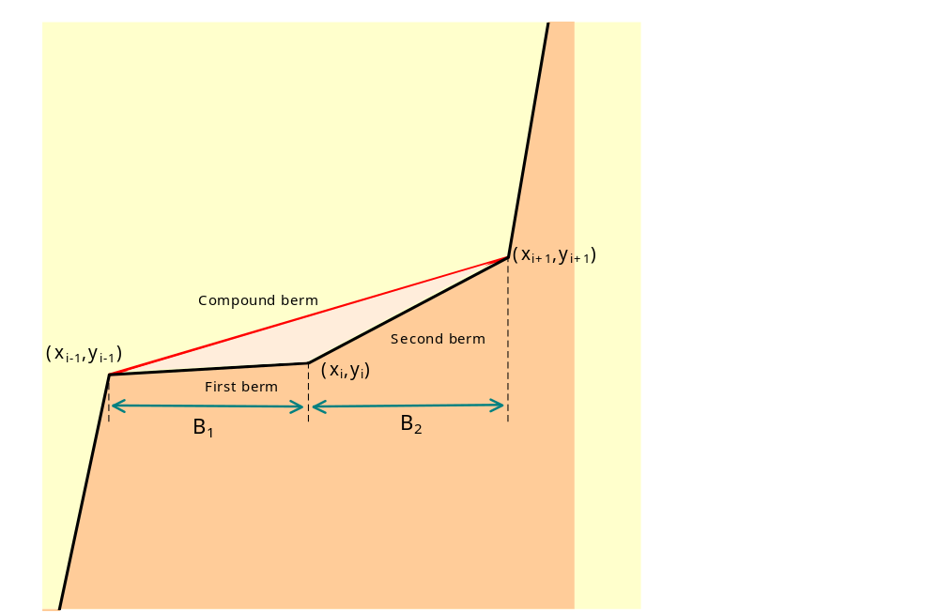
Figure 3-1: Merging two berms

Calculate influence factors angle of wave attack

Input:
ϕ | Wave direction | (° with reference to North)
ψ | Dike normal | (° with reference to North)
H_{m0} | Significant wave height | (m)
T_{m-1,0} | Spectral wave period | (s)

Output:
β | Angle of wave attack | (°)
γ_{β,z} | Influence factor angle of wave attack for 2% wave run-up | (-)
γ_{β,o} | Influence factor angle of wave attack for overtopping | (-)
H_{m0} | Significant wave height | (m)
T_{m-1,0} | Spectral wave period | (s)

Calculation:
Calculate the angle of wave attack: β = |ϕ - ψ|, if β>180 then β = 360 - β
Calculate the influence factor for the angle of wave attack for 2% wave run-up ([TAW, 2002], formula 8, page 16): γ_{β,z} = 1 – 0.0022 × min (β,80)
Calculate the influence factor for the angle of wave attack for overtopping ([TAW, 2002], formula 9, page 16): γ_{β,o} – 1- 0.0033 × min (β,80)
Adjust the wave parameters if 80 < β < 110 ([TAW, 2002], page 16):
H_{m0} = H_{m0} × (110-β)/30, if β>110 then H_{m0} = 0
T_{m-1,0} = T_{m-1,0} × √([110-β]/30), Remark: if β>110 then T_{m-1,0} is not adapted.

Split cross section for at least one wide berm
A cross section contains a wide berm if the berm width is between one-quarter of the wave length and one wave length. The wave length is equal to the squared wave period multiplied by a constant. For small wave periods the wave length is also small and berms can easily be larger than one-quarter of the wave length. If the cross section contains at least one wide berm split the cross section into two different cross sections. The procedure to split the cross section is shown in Figure 3-2. If the cross section contains more than one wide berm, all are split with the procedure shown in Figure 3-2 and it gives two cross sections: one with berms in which the width of the berms equal to one-quarter of the wave length and one cross section with berms in which the width of the berms is equal to the wave length.

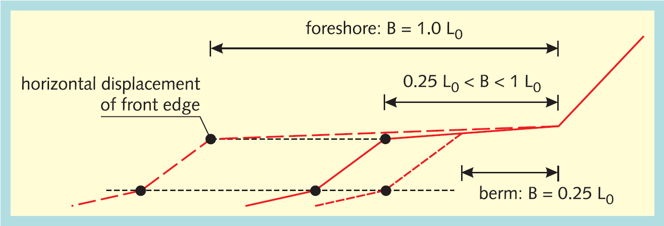
Figure 3-2: Procedure to split a cross sector with a wide berm into two separate cross sections

Input:
T_{m-1,0} | Spectral wave period | (s)
x | x-coordinates cross section with at least wide berm | (m)
y | y-coordinates cross section with at least wide berm | (m+NAP)
g | gravity force | (m²/s)

Output:
x_{B} | x-coordinates cross section with no berms with a berm width more than one-quarter of the wave length | (m)
y_{B} | y-coordinates cross section with no berms with a berm width more than one-quarter of the wave length | (m+NAP)
x_{F} | x-coordinates cross section with at least one foreshore | (m)
y_{F} | y-coordinates cross section with at least one foreshore | (m+NAP)
L₀ | Wave length | (m)
N_{b} | Number of wide berms | (-)

Calculation:
- Calculate the wave length: L₀ = g T_{m-1,0}² / 2π
- Determine the number of wide berms (N_{b})
- Determine the cross section with the berm (x_{B}, y_{B}) through interpolation using x and y. Figure 3-2 gives the derivation method.
- Determine the cross section with the foreshore (x_{F}, y_{F}) through interpolation using x and y. Figure 3-2 gives the derivation method.

Start specific computation for cross section

Input:
H_{m0} | Significant wave height | (m)
T_{m-1,0} | Spectral wave period | (s)
β | Angle of wave attack | (°)
γ_{β,z} | Influence factor angle of wave attack for 2% wave run-up | (-)
γ_{β,o} | Influence factor angle of wave attack for overtopping | (-)
x | x-coordinates cross section | (m)
y | y-coordinates cross section | (m+NAP)

Output:
z_{2%} | 2% wave run-up | (m)
q₀ | wave overtopping discharge | (m³/s)

Calculation:
- If H_{m0} = 0, z_{2%} = 0, q₀ = 0.
- If cross section contains no foreshore use the method in chapter 4 to
calculate 2% wave run-up (z_{2%}) and overtopping discharge (q₀) chapter 4 (page 9)
- If cross section contains a foreshore use the method in chapter 5 to
calculate 2% wave run-up (z_{2%}) and overtopping discharge (q₀) chapter 5 (page 19)

Combine computation results for cross sections
If the original cross section – i.e. the cross section chosen by the user – consists at least one wide berm this cross is split into two cross sections. For both cross sections a separate computation is made. The results of these two computations have to be combined ([TDR, 2005], section 6.12.1 and section 7.8.1 (in one document two practically the same sections (exceptional))).

Input:
z_{2%,B} | 2% wave run-up cross section with no berms with a berm width more than one-quarter of the wave length | (m)
q_{0,B} | wave overtopping discharge cross section with no berms with a berm width more than one-quarter of the wave length | (m³/s)
z_{2%,F} | 2% wave run-up cross section with at least one foreshore | (m)
q_{0,F} | wave overtopping discharge cross section with at least one foreshore | (m³/s)
B | Berm widths of wide berms | (m)
L₀ | Wave length | (m)
N_{b} | Number of wide berms | (-)

Output:
z_{2%} | 2% wave run-up cross section | (m)
q₀ | wave overtopping discharge cross section | (m³/s)

Calculation:
- Calculate z_{2%} = z_{2%,B} + (z_{2%,F} - z_{2%,B}) x (∑B_{i} - N_{b} L_{op}/4) / (N_{b} (L_{op} - L_{op}/4))
- Calculate q_{o} = q_{o,B} + (q_{o,F} - q_{o,B}) x (∑B_{i} - N_{b} L_{op}/4) / (N_{b} (L_{op} - L_{op}/4))

Computation method
This chapter describes the computation method to calculate the wave overtopping discharge over the crest of a dike. First the calculation steps are presented (paragraph 4.1). In the next paragraph the detail functions are described.

Calculation steps
Adjustment of non-horizontal berms section 4.2.1 (page 10)
Iterate until 2% wave run-up reaches an equilibrium
Calculate representative slope angle section 4.2.3 (page 12)
Calculate z_{2%,smooth} (for γ_{b} = 1 and γ_{f} = 1) section 4.2.2 (page 11)
Calculate influence factor roughness on slope section 4.2.4 (page 13)
Calculate z_{2%,rough} (for γ_{b} = 1) section 4.2.2 (page 11)
Calculate influence factor berms section 4.2.6 (page 14)
Calculate 2% wave run-up section 4.2.2 (page 11)
Calculate wave overtopping discharge section 4.2.9 (page 18)

Punt van discussie
Het bovenstaande rekenschema is overgenomen uit [TAW, 2002]. In dit schema wordt voor de berekening van de z_{2%} golfoploop eerst de invloed van de ruwheid op het talud (stap 2c) berekend en vervolgens de invloed van de bermen (stap 2e). In de formules voor de ruwheid van het talud komt de invloedsfactor voor de bermen voor (calculation step 5 van paragraaf 4.2.4). In de formules voor het bereken van de invloed van de bermen komt de invloedsfactor voor de ruwheid niet voor. Het lijkt daarmee logischer om eerst de invloed van bermen (stap 2e) te berekenen en dan pas de invloed van ruwheid (stap 2c). In dit Functional Design is vooralsnog de volgorde uit [TAW, 2002] aangehouden. [TRD, 2005] geeft in de paragrafen 7.4 en 7.5 de indruk dat er sprake is van deze omkering.

Opmerking
Garanties dat de iteratieprocedure altijd convergeert kunnen niet gegeven worden. Dit zal tijdens de implementatie moeten blijken. Ook het stopcriterium zal tijdens de implementatie bepaald moeten worden. Het stopcriterium zal een functie zijn van het verschil tussen twee opeenvolgende iteratiestappen.

Detailed functions

Adjustment of non-horizontal berms
Computations of wave run-up and wave overtopping for cross sections with non-horizontal berms are performed with cross sections with non-horizontal berms. So, in addition to the cross section with non-horizontal berms, a calculation cross section with just horizontal berms is derived from the original cross section. The derivation is shown in Figure 4-3 for one berm. Each berm is treated in this way.

Input:
x | x-coordinates cross section with non-horizontal berms | (m)
y | y-coordinates cross section with non-horizontal berms | (m+NAP)

Output:
x | x-coordinates cross section with horizontal berms | (m)
y | y-coordinates cross section with horizontal berms | (m+NAP)

Calculation:
Calculate the middle of the berm: x_{m} = (x_{i} + x_{i+1}) / 2, y_{m} = (y_{i} + y_{i+1}) / 2
Calculate the lower slope: tan α_{i-1} = (y_{i} - y_{i-1}) / (x_{i} - x_{i-1})
Calculate the upper slope: tan α_{i+1} = (y_{i+2} - y_{i+1}) / (x_{i+2} - x_{i+1})
Calculate the starting point of the horizontal berm:
y_{i}' = y_{m} and x_{i}' = x_{i-1} + (y_{i}' - y_{i-1}) / tan α_{i-1}
Calculate the end point of the horizontal berm:
y_{i+1}' = y_{m} and x_{i+1}' = x_{i+1} + (y_{i+1}' - y_{i+1}) / tan α_{i+1}

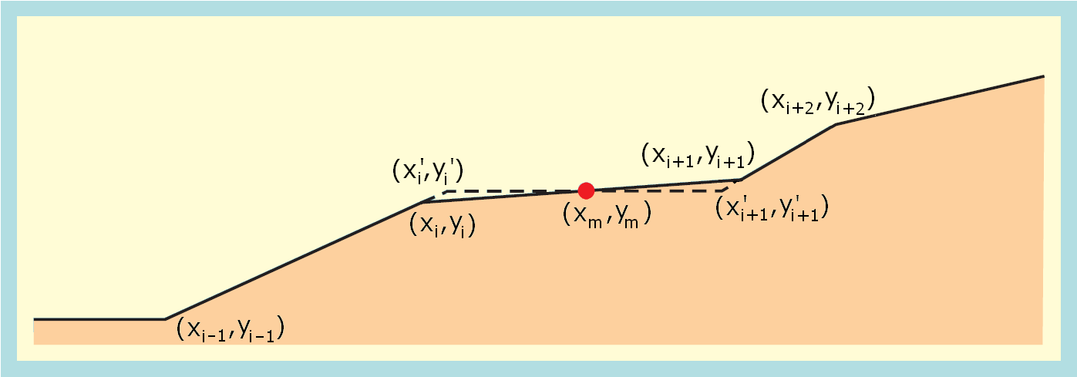
Figure 4-3: Adjustment of a non-horizontal berm

Opmerking
In Hydra-Zoet is aan een berm de voorwaarde opgelegd dat deze een helling moet hebben van minimaal 1 op 100 (en maximaal 1 op 15). Het is niet gelukt om de achtergrond van deze minimale hellingsvoorwaarde te achterhalen. Voorstel is om deze voorwaarde te laten vervallen, tenzij er steekhoudende argumenten zijn om toch vast te houden aan de minimale helling van 1 op 100. Een argument om de eis van een minimale helling van 1 op 100 te laten vervallen is dat in de berekening van de golfoploop en het overslagdebiet gerekend wordt met een profiel zonder helling.

Calculate 2% wave run-up

Input:
H_{m0} | Significant wave height | (m)
T_{m-1,0} | Spectral wave period | (s)
tan α | Representative slope angle | (-)
γ_{b} | Influence factor berms | (-)
γ_{f} | Influence factor roughness | (-)
γ_{β} | Influence factor angle of wave attack | (-)
f_{run-up1} | Model factor wave run-up 1 (1.75 in [TAW, 2002], formula 3a, page 8) | (-)
f_{run-up2} | Model factor wave run-up 2 (4.3 in [TAW, 2002], formula 3b, page 9) | (-)
f_{run-up3} | Model factor wave run-up 3 (1.6 in [TAW, 2002], formula 3b, page 9) | (-)

Output:
ξ₀ | Breaker parameter | (-)
s₀ | Wave steepness | (-)
z_{2%} | 2% wave run-up | (m)

Calculation:
Calculate the wave steepness ([TAW, 2002], page 8): s₀ = 2π H_{m0} / (g T²_{m-1,0})
Calculate the breaker parameter ([TAW, 2002], formula 1, page 8): ξ₀ = tan α / √s₀
Calculate the 2% wave run-up for small breaker parameters ([TAW, 2002], formula 3a, page 8): z_{2%,small} = H_{m0} f_{run-up1} γ_{b} γ_{f} γ_{β} ξ₀
Calculate the 2% wave run-up for large breaker parameters ([TAW, 2002], formula 3b, page 9): z_{2%,large} = H_{m0} γ_{f} γ_{β} (f_{run-up2} – f_{run-up3}/√ξ₀)
Calculate the 2% wave run-up ([TAW, 2002], page 9): z_{2%} = min (z_{2%,small}, z_{2%,large})

Calculate representative slope angle

Input:
SWL | Still water line (local water level) | (m+NAP)
H_{m0} | Significant wave height | (m)
z_{2%} | 2% wave run-up | (m)
x | x-coordinates cross section without berms | (m)
y | y-coordinates cross section without berms | (m+NAP)

Output:
tan α | Representative slope angle | (-)

Calculation:
The calculation of the representative slope is displayed in Figure 4-4 ([TAW, 2002], page 13). The representative slope angle is the average slope in the zone between SWL – 1.5 H_{m0} and SWL + z_{2%}. Any berms do not have to be taken into account in this calculation. The first time the representative slope angle is calculated, the 2% wave run-up is unknown. As initial value for the wave run-up z_{2%} = 1,5 H_{m0} is used.

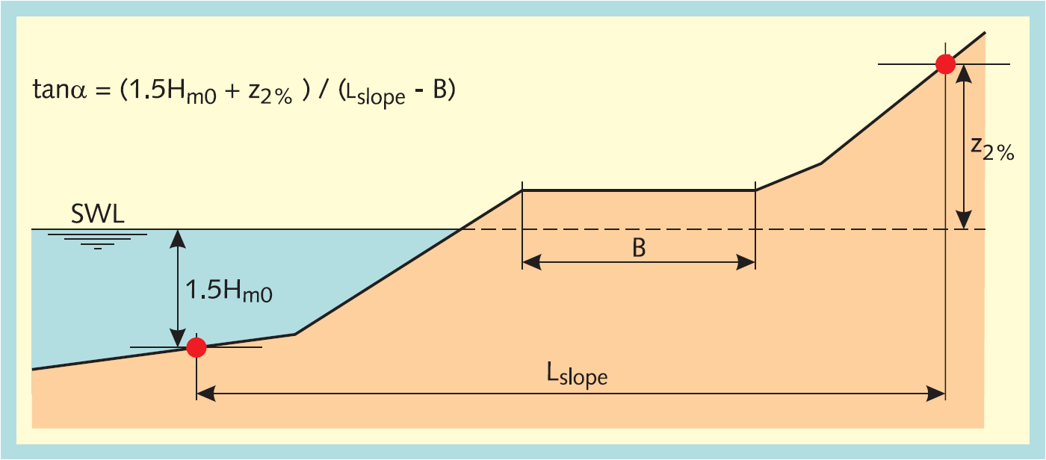
Figure 4-4: Calculation of the representative slope for a cross section with multiple sections.

Since we demand the cross section without berms as input, the calculation of the representative slope angle uses the following steps:

Determine y_{lower} = max (SWL – 1.5 H_{m0}, y₁)
Determine the corresponding x_{lower} through interpolation using x and y
Determine y_{upper} = min (SWL + z_{2%}, y_{N})
Determine the corresponding x_{upper} through interpolation using x and y
Calculate the representative slope angle: tan α = (y_{upper} - y_{lower}) / (x_{upper} - x_{lower})

Calculate influence factor roughness on slope

Input:
x | x-coordinates cross section | (m)
y | y-coordinates cross section | (m+NAP)
r | roughness factor dike segments | (-)
SWL | Still water line (local water level) | (m+NAP)
z_{2%,smooth} | 2% wave run-up without roughness | (m)
γ_{b} | Influence factor berms | (-)
ξ₀ | Breaker parameter | (-)

Output:
γ_{f} | Influence factor roughness | (-)

Calculation:
Determine y_{lower} = max (SWL – 0.25 z_{2%,smooth}, y₁)
Determine y_{upper} = min (SWL + 0.5 z_{2%,smooth}, y_{N})
Determine the roughness (γ_{f,i}) and the length (L_{i}) of the segments between y_{lower} and y_{upper}
Calculate the influence factor for the roughness ([TAW, 2002], formula 19, page 25):
γ_{f} = ∑( L_{i} γ_{f,i}) / ∑L_{i}
Adjust the influence factor if γ_{b} ξ₀ > 1.8 ([TAW, 2002], page 20):
γ_{f} = min (1, γ_{f} + (1-γ_{f}) × (γ_{b} ξ₀-1.8) / (10-1.8))

Opmerking
In [Venema, 2010] is opgemerkt dat de grenswaarde 1.8 uit calculation step 1.5 een functie is van γ_{b}. Afhankelijk van de waarde van γ_{b} varieert de grenswaarde waarbij de uitgerekende γ_{f} (in calculation step 4) nog wordt aangepast (in calculation step 5) van 1.95 (voor γ_{b} = 0.6) tot 1.77 (voor γ_{b} = 1.0). De grenswaarde kan echter niet analytisch bepaald worden (alleen numeriek). In [Venema, 2010] wordt voorgesteld om de numerieke berekening eenmalig uit te voeren voor een flink aantal γ_{b}'s en de grenswaarde in calculation step 5 hieruit te bepalen. In [Venema, 2010] wordt hierbij echter uitgegaan vaste waardes f_{run-up1} = 1.75, f_{run-up2} = 4.3 en f_{run-up3} = 1.6 (section 4.2.2). Er is echter geen sprake van deze vaste waardes. Dit maakt dat de numerieke berekening echt uitgevoerd moet worden. Voorgeteld wordt om dat pad niet te bewandelen, maar gebruikt te maken van de in z'n algemeenheid enigszins onjuiste waarde van 1.8 (conform [TAW, 2002], page 20).

Calculate influence factor berms
The permitted cross sections have a maximum of two berms (section 3.2). The computation of the influence of the berms is made with the calculation cross section with only horizontal berms (section 4.2.1)with a maximal width of one-quarter of the wave length (section 3.5). The computation is made for each berm separately and afterwards the influences of the berms are combined.

Input:
x | x-coordinates cross section with horizontal berms and berm width is maximal one-quarter of the wave length | (m)
y | y-coordinates cross section with horizontal berms and berm width is maximal one-quarter of the wave length | (m+NAP)

Output:
γ_{b} | Influence factor berms | (-)

Calculation:
- Calculate influence factor first berm section 4.2.6 (page 14)
- if influence factor first berm equals 0.6 no further computations are needed:
total influence factor berms is equal tot 0.6.
- if a second berm exists:
calculate influence factor second berm section 4.2.6 (page 14)
- if influence factor second berm equals 0.6 no further computations are needed:
total influence factor berms is equal tot 0.6.
- if applicable combine influence factors berms section 4.2.7 (page 16)
- Calculate adjustment of influence factors section 4.2.8 (page 17)

Calculate influence factor one berm
a berm in a cross section affects the wave run-up and the wave overtopping. The width of a berm is significant and also the position of the berm in relation to the still water line (SWL). The total influence of one berm is the combination of the influences of these two elements.

Input:
SWL | Still water line (local water level) | (m+NAP)
H_{m0} | Significant wave height | (m)
z_{2%%,rough} | 2% wave run-up with roughness | (m)
x | x-coordinates cross section with horizontal berms and berm width is maximal one-quarter of the wave length | (m)
y | y-coordinates cross section with horizontal berms and berm width is maximal one-quarter of the wave length | (m+NAP)

Output:
γ_{b} | Influence factor berms | (-)
B | Berm width | (m)
L_{berm} | Length of the cross section with influence of the berm | (m)
r_{dh} | depth of the berm in relation to the water level | (m)

Calculation:
In wave run-up formulas, the influence of a berm is calculated with a berm factor, in which two influences are taken into account:
- the influence of the width of the berm in relation to the wave height and the shape of the cross section (parameter r_{b})
- depth of the berm in relation to the water level (parameter r_{dh}).

- Determine L_{berm} – the length of the cross section against which the length of the berm is deposed – through interpolation using x and y. Figure 4-5 shows the derivation method. Note that the still water line (SWL) isn't relevant.

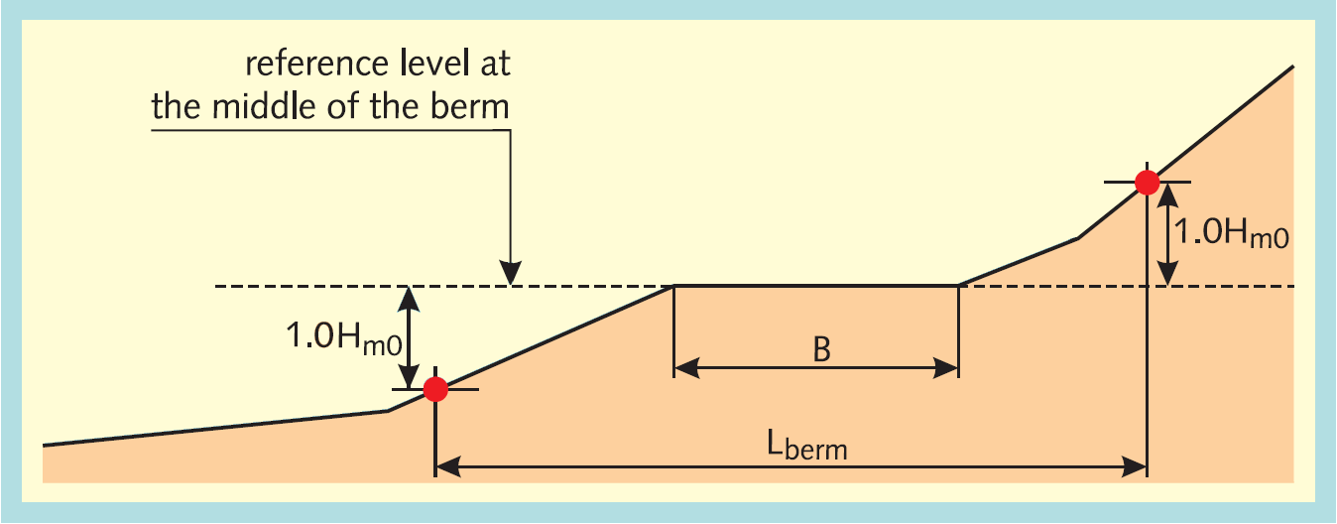
Figure 4-5: Computation of L_{berm} the length of the cross section against which the length of the berm is deposed.

- Calculate the influence of the width of the berm in relation to L_{berm}: r_{b} = B / L_{berm}
- Calculate the difference between the berm height and the still water line d_{h} = SWL - h_{berm}
- Calculate the influence of the depth of the berm in relation to the still water line:
r_{dh} = 0.5 + 0.5 x cos (π d_{h} / x) with:
x = z_{2%} if z_{2%} > -d_{h} > 0 (Figure 4-6),
x = 2H_{m0} if 2H_{m0} > d_{h} > 0 (Figure 4-7).
- r_{dh} = 1 if -d_{h} ≥ z_{2%} or d_{h} ≥ H_{m0}
- calculate γ_{b} = 1 - r_{b} x (1 - r_{dh})
- γ_{b} = 0.6 if γ_{b} < 0.6.

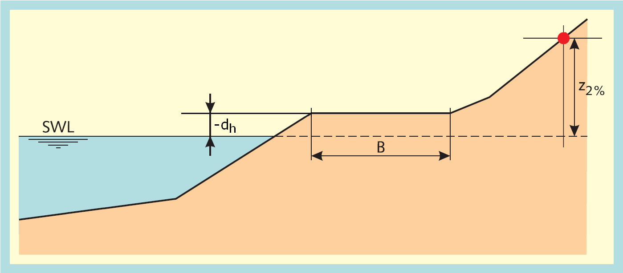
Figure 4-6: If the position of the berm is above the water level the parameter r_{dh} is less than 1 (r_{dh} < 1) as the difference of the berm height and the still water line is less than Z_{2%} (Z_{2%} > -d_{h})

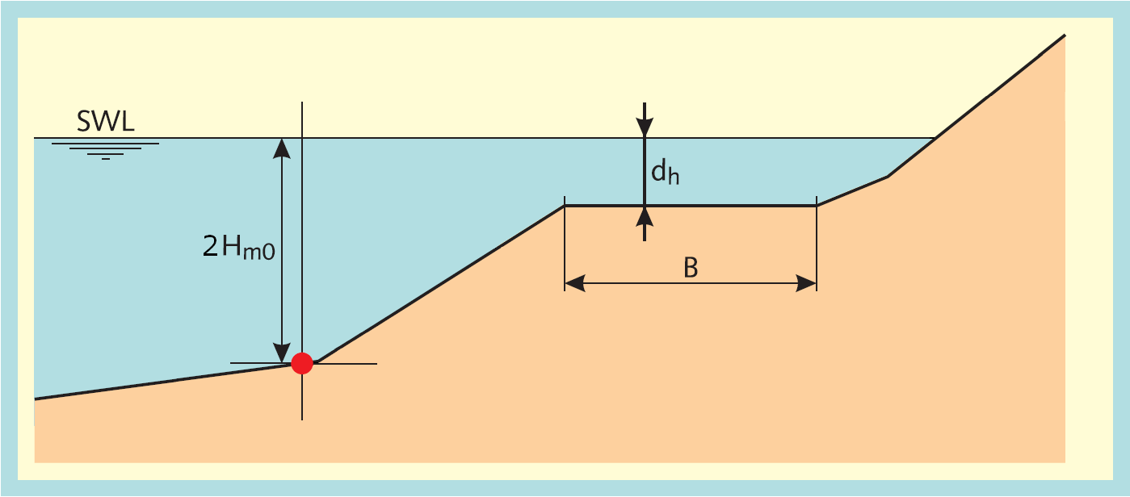
Figure 4-7: If the position of the berm is below the water level the parameter r_{dh} is less than 1 (r_{dh} < 1) as the difference of the berm height and the still water line is less than 2H_{m0} (2H_{m0} > d_{h})

Opmerking
In Figure 4-5 is de hoogte 1.0H_{m0} twee keer weergegeven, in Figure 4-6 is de hoogte z_{2%} weergegeven en in Figure 4-7 is de hoogte 2.0H_{m0} weergegeven. Onduidelijk is of en welke hoogtes bijgesteld moeten worden voor de hoogte van de teen en de hoogte van de kruin.

In de documentatie van Hydra-Ring staat:
In Hydra-Ring this division (d_{h} / x) is implemented, where the value for z2% is evaluated before being used in this formula. If the crest height is lower than the z2% wave run-up level, the difference between the crest height and the water level is used. This evaluating is only used for cases, where the SWL is below the berm. On the other hand, if the SWL is above the berm and 2 times H_{m0} is below the toe of the dike no correction is used for x. This parameter is still equal to 2H_{m0}.

Combine influence factors berms

Input:
B | Berm width (vector) | (m)
L_{berm} | Length of the cross section with influence of the berm (vector) | (m)
r_{dh} | depth of the berm in relation to the water level (vector) | (m)

Output:
γ_{b} | Influence factor berms | (-)

Calculation:
- calculate for all berms i: f₁(i) = B(i) x (1 –r_{dh}(i))
- calculate for all berms i: f₂(i) = (L_{berm}(i) - B(i)) x (1 - r_{dh}(i))
- calculate f₃ = ∑ f₁(i)
- calculate f₄ = ∑ (f₁(i) x f₂(i))
- calculate f₅ = ∑ {f₁(i) x (1 - r_{dh}(i))}
- calculate γ_{b} = 1 - f₅ /(f₄ / f₃ + f₃)
- If γ_{b} is less than 0.6, γ_{b} is set equal to 0.6.

N.B. The above formulas give in case of only one berm exactly the formula used for one berm:
γ_{b} = 1 - (B/L_{berm}) x (1 - r_{dh}) given in section 4.2.6.

Calculate adjustment of influence factors

Input:
γ_{b} | Influence factor berms | (-)
γ_{β} | Influence factor angle of wave attack (2% wave run-up or overtopping) | (-)
γ_{f} | Influence factor roughness | (-)
ξ₀ | Breaker parameter | (-)

Output:
γ_{b} | Influence factor berms | (-)
γ_{β} | Influence factor angle of wave attack (2% wave run-up or overtopping) | (-)
γ_{f} | Influence factor roughness | (-)

Calculation:
A requirement of the influence factors (γ_{b}, γ_{f}, γ_{β}) is that the product of these influence factors (γ_{b} x γ_{f} x γ_{β}) isn't less than 0.4. In case it is less the minimum factor of 0.4 should be used for the product of the influence factors ([TAW, 2002], formula 6, page 12). For some calculation steps in the computations of the wave run-up (paragraph 4.2.2) and in the computations of the wave overtopping (paragraph 4.2.9) the total influence factor is used and for other steps the individual influence factors are used. In order to use consistent influence factors all the influence factors are adapted if the total influence factor is less than 0.4. The adjustment ensures that the product of the influence factors is equal to 0.4. The adjustment of the influence is only calculated if the product of the influence factors is less than 0.4.

Calculate the total influence factor
- if ξ₀ x γ_{b} < 1.8, then γ_{t} = γ_{b} x γ_{f} x γ_{β}
- if ξ₀ x γ_{b} ≥ 1.8, then γ_{t} = γ_{f} x γ_{β}
Calculate the ratio for the influence factor of roughness in relation to the minimum influence factor of roughness 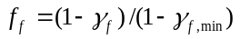, where 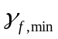=0.55 ([TDR, 2005], page 26 and 28).
Calculate the ratio for the influence factor of berms in relation to the minimum for influence factor of berms 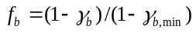, where 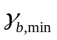=0.6 ([TDR, 2005], page 26 and 28).
Calculate the ratio for the influence factor of wave attack in relation to. the minimum for influence factor of wave attack 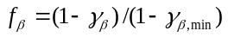, where 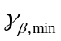= 0.824 for 2% wave run-up ([TDR, 2005], page 26) and =0.736 for wave overtopping ([TDR, 2005], page 28).
Calculate the sum of the ratio's: 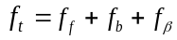
Adapt the influence factors:
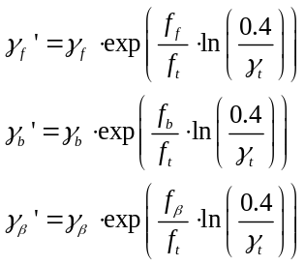

Calculate wave overtopping discharge

Input:
y | y-coordinates cross section | (m+NAP)
h | Still water line (local water level) | (m+NAP)
H_{m0} | Significant wave height | (m)
tan α | Representative slope angle | (-)
γ_{b} | Influence factor berms | (-)
γ_{β,o} | Influence factor angle of wave attack for overtopping | (-)
γ_{f} | Influence factor roughness | (-)
f_{b} | model factor for breaking waves (4.3 in [TAW, 2002], formula 22, page 28) | (-)
f_{n} | model factor for non-breaking waves (2.3 in [TAW, 2002], formula 23, page 28) | (-)
f_{swallow} | model factor for shallow waves (0.21 in [TAW, 2002], formula 26, page 33) | (-)
ξ₀ | Breaker parameter | (-)
g | gravity force | (m²/s)

Output:
q₀ | wave overtopping discharge | (m³/s)

Calculation:
Calculate adjustment of influence factors section 4.2.8 (page 17)
If the breaker parameter ξ₀ ≤ 5, calculate the dimensionless overtopping discharge for breaking waves ([TAW, 2002], formula 22, page 26):
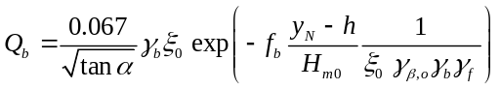
If the breaker parameter ξ₀ < 7, calculate the dimensionless overtopping discharge for non-breaking waves ([TAW, 2002], formula 23, page 26):
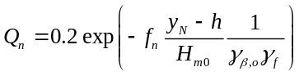
If the breaker parameter ξ₀ > 5, calculate the dimensionless overtopping discharge for swallow water ([TAW, 2002], formula 26, page 31):
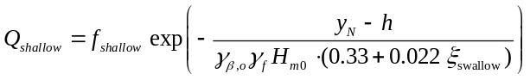, with ξ_{swallow} = max(7, ξ₀).
Calculate the overtopping discharge:
- If the breaker parameter ξ₀ ≤ 5 ([TAW, 2002], formulae 22 & 23, page 26):
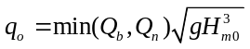
- If the breaker parameter 5 < ξ₀ < 7 ([TAW, 2002], page 31):
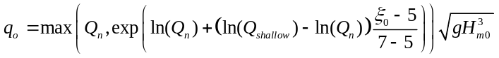
Opmerking
Bovenstaande formule kan natuurlijk ook vervangen worden door:
Als Q_{n} > Q_{swallow} dan q_{o} = Q_{n} √(g H_{m0}³)
anders de logaritmische interpolatie met Q_{n} en Q_{swallow}

- If the breaker parameter ξ₀ ≥ 7 ([TAW, 2002], formula 26, page 31):
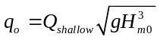

Foreshore
A cross section contains a foreshore if the length of a berm segment (the gradient of the segment has a maximum of 1:15) is at least one wave length (L₀). If the cross section contains a foreshore there are three possibilities for the still water line (SWL):
- The still water line is below the front of the foreshore (Figure 5-8):
- Adjust non-horizontal foreshores to horizontal foreshores section 4.2.1 (page 10)
- The wave overtopping discharge is equal to 0.
- For the computation of the 2% wave run-up (z_{2%}) use the calculation steps in section 4.1. The difference between the SWL and the height of the horizontal foreshore is the maximum of the 2% wave run-up.
- The still water line is on the foreshore (Figure 5-9):
- The 2% wave run-up (z_{2%}) is equal to 0.
- The wave overtopping discharge is equal to 0.
- The still water line is above the foreshore (Figure 5-10):
- The cross section is adjusted by removing all cross section segments below the still water line. So the foreshore is removed and all lower segments of the cross section.
- The wave height is adjusted: H_{m0} = min(H_{m0}, d_{h} / 2), with d_{h} the water depth at the end of the foreshore (Figure 5-10).
- No adjustments to the wave period T_{m-1,0} and the wave direction ϕ.
- Start computation method in section 4.1 after the above adjustments.

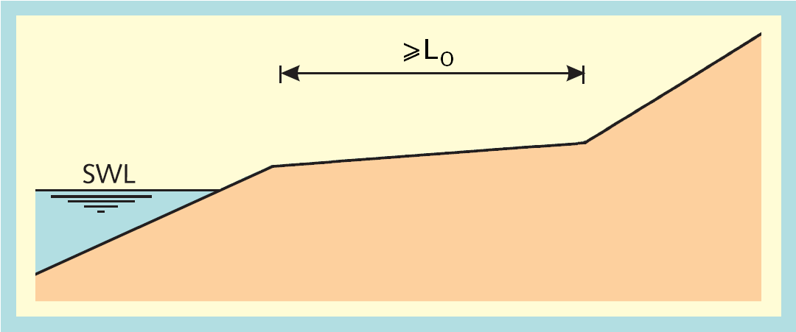
Figure 5-8: Still water line (SWL) below the front of the foreshore

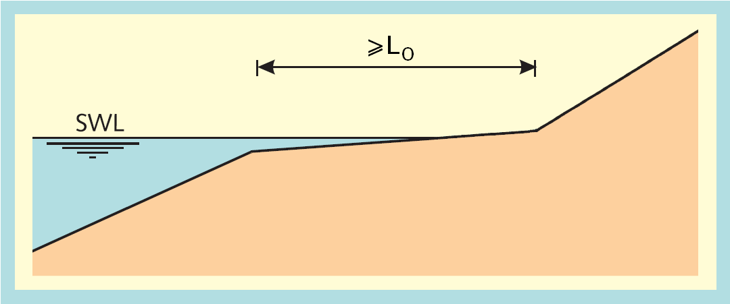
Figure 5-9: Still water line (SWL) on the foreshore

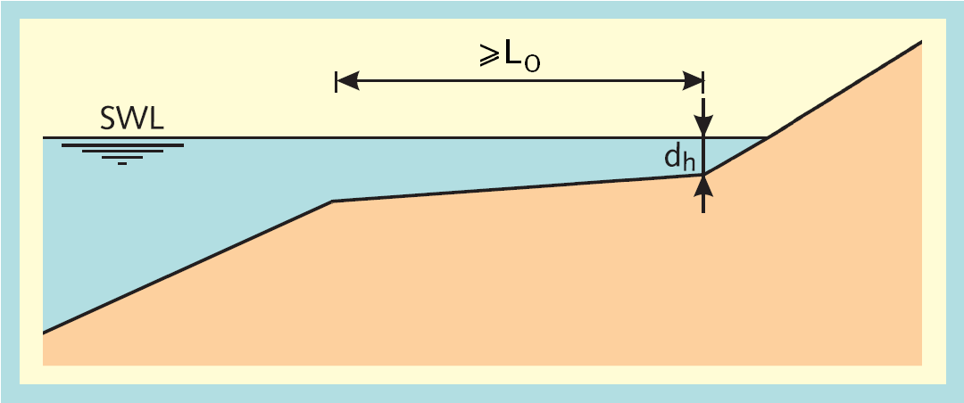
Figure 5-10: Still water line (SWL) above the foreshore

References
[Duits en Kuijper, 2012]
Hydra-Zoet – Gebruikershandleiding – Versie 1.6 [HKV-rapport PR1564]. M.T. Duits en B. Kuijper. HKV lijn in water. Lelystad, juli 2012.

[TAW, 2002]
Technisch Rapport Golfoploop en Golfoverslag bij Dijken. J.W. van der Meer. Technische Adviescommissie voor de Waterkeringen (TAW). Delft, mei 2002.

[TDR, 2005]
Technisch definitierapport PC-Overslag, bijgewerkt tot en met juni 2005.

[Venema, 2010]
Memorandum Invloedsfactor ruwheid. H. Venema. Deltares. Delft, maart 2010.

